**Department of Computer Science & Engineering**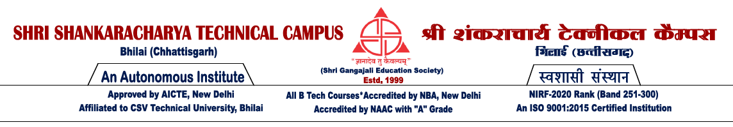

**MAJOR PROJECT-I SYNOPSIS**

**Semester: 7th (Session :Nov-Dec 2024)**

**Name of the Student (With Roll Number):**

**Name- Anurag V Kulkarni Roll No.- 301402221011**

**Project Title:** Mood-Matrix

**Synopsis of Project:** The objective of the program given is to detect and analyse object of interest(face) in real time and to keep track of the same object. This is a simple example of how to detect and analyse human emotion in Python. You can try to use training samples of any other object of your choice to be detected by training the classifier on required objects.

**Hardware/ Software Requirement:**  A broadband connection to the internet, built-in web/USB camera,2.2 GHz Intel 2nd-generation or better processor to support HD video, supported operating system, operating system supporting version Python 2.7.x or more, Library NumPy and OpenCV

**Application of Project:**

Identification and Verification: Face recognition systems are primarily designed to identify and verify individuals based on their facial features. The outcome is successful identification or verification of a person's identity.

Security Enhancement: Many face recognition systems are used for security purposes, such as access control to secure areas or unlocking devices (e.g., smart phones). The outcome is improved security by preventing unauthorized access

**Future work (Scope of work):**

The future scope is promising and agile. Continued research and development efforts can further enhance the system's capabilities in handling complex scenarios, such as varying lighting conditions, facial expressions, and occlusions, to improve accuracy and adaptability. Exploration of multimodal biometric fusion techniques, incorporating additional biometric modalities like voice or iris recognition, could enhance the system's performance and reliability.

**Name of the Guide:…………………………………………Signature …………………**

**Name of the Co Guide:…………………………………………Signature …………………**

**HOD**

**Dept. of CSE**